Staying Connected…
Exciting and important news
Our class is using ClassDojo!
Hi families,

I will be using ClassDojo to keep in touch
with all of you throughout the year.
We’ll be able to communicate and share
messages, updates and photos. We’ll also be
able to share learning videos and resources.

I will be sending you an invite in the next few
weeks – either through your email or cell phone.
If either of these have changed recently, please
let me know.
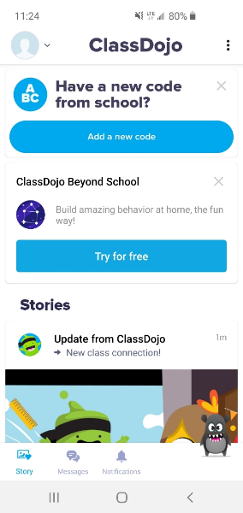
You will have an option to enter a school code. If the original invite I sent doesn’t work, please contact me for a code. Otherwise, X out.
I’d like all families who can to join me and
sign up for ClassDojo! You can use it on any
device; it is a simple, free mobile app for iOS
and Android, and can also be used from a
computer at: www.classdojo.com.
ClassDojo Beyond School is an OPTIONAL paid subscription to use at home. You DO NOT need to use this if you don’t want to. Just X out.

If you do not have access to a mobile device or
computer, don’t worry - I’ll still be in contact
with you via calls and other activities.

